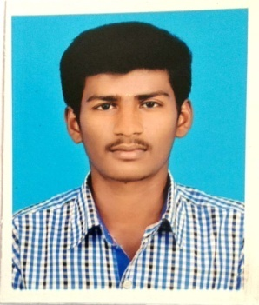**VENKATESH D**

Do.no :14/1-14,soundamman kovil street,chamrajpet(po),

Mecheri,mettur(tk),salem(dt),pin-636451.

Email : venkateshdass27@gmail.com

Mobile : +91 8667546662.

**CAREER OBJECTIVE**

To obtain a position of responsibilities that utilize my skills and experience and keen to work in an environment where I can enrich my knowledge .

**ACADEMIC DETAILS**

|  |  |  |  |  |
| --- | --- | --- | --- | --- |
| **Course** | **Name of the Institution** | **University/ Board** | **Year of completion** | **Aggregate (%) / CGPA** |
| B.E.,(ECE) | K.S.R. College of Engineering, Tiruchengode. | Autonomous | 2020(pursuing) | 7.01 |
| HSC | MAM Higher Secondary School, Mettur. | State board | 2016 | 77.58% |
| SSLC | G0VT.Hr.Sec.School, Mecheri.. | State board | 2011 | 89.4% |

**AREAS OF INTEREST**

* VLSI Design
* Wireless Communication System

**TECHNICAL SKILLS**

Programming Languages : Basic C,C++ programing, JAVA, SQL.

Packages : Microsoft Office (Word, Excel, Power Point)

**MINI PROJECT**

**Project 1:** Water Level Indicator Alarm

Project Description:

In this project a water level indicator circuit is designed. It is very useful to indicate the water levels in a tank. Whenever tank gets filled, we get alerts on particular levels.

**Project 2:** Light Detector Using NAND Gate

Project Description:

In this project a light detector circuit using a NAND gate chip is designed. A light detector circuit is a circuit that can detect a light. When a bright light shines on the circuit, the LED turns ON.

**PERSONAL SKILLS**

* Quick learner
* Good Listener

**EXTRA CURRICULAR ACTIVITIES**

* Attend the mobile servicing workshop in KSR College of Engineering.
* Interested in sports.

**PERSONAL DETAILS**

Father's Name : Dhasappan N

Mother's Name : Obulakshmi D

Date of Birth and age : 27.06.1999 and 21years

Gender : Male

Languages Known : Tamil, English and Kannada

Nationality : Indian

Marital status : Unmarried

**DECLARATION**

I hereby declare that the above furnished details are true and correct to the best of my knowledge.

Place :

Date : (VENKATESH D)